SOFT SKILLS CLASSES FOR PERSONALITY DEVELOPMENT
Understanding the need of one’s personality that enables an individual to act more genuinely and effectively in a team environment, students are encouraged to deliver presentations in the class which help them to develop ability to gather information, make decisions and interact with others. Soft skills classes empower students with confidence, boldness, expressiveness etc., also the students’ personality is overall developed.
REFRESHER COURSES AND ORIENTATION PROGRAMS ORGANIZED FOR IMPROVEMENTS IN TEACHING
1. Refresher courses have been organized by the department involving experienced faculty and subject experts from various in Subjects like thermal engineering, theory of machines, mechanics of solids, fluid mechanics, design of machine elements, CAD/CAM, and engineering materials etc. This has helped the faculty (especially junior faculty) to improve their knowledge and also learn effective techniques of teaching these subjects.
2. The department conducts seminars on latest research topics which is to be delivered by faculty members in turns every week so that the faculty are abreast with the latest developments in their fields of interest and specialization.
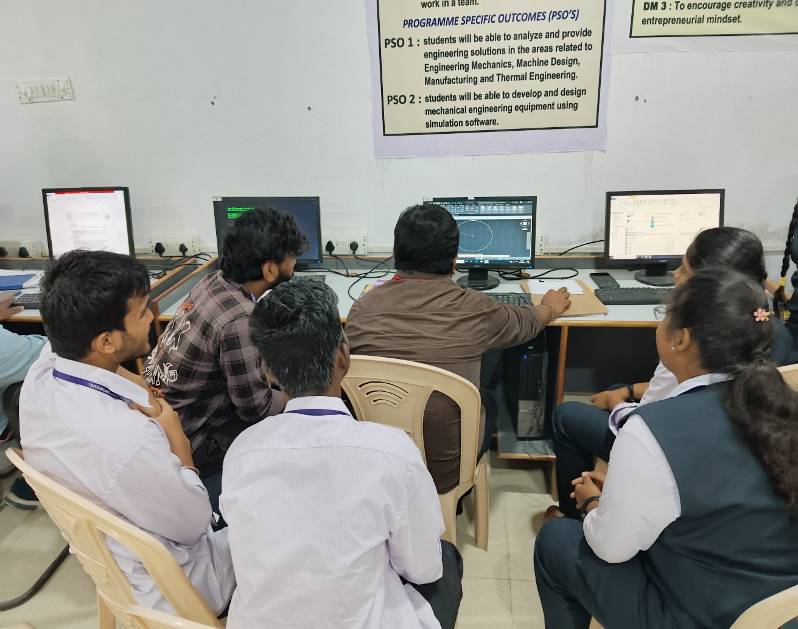
Students Learning Computer-Aided Design Using AutoCAD
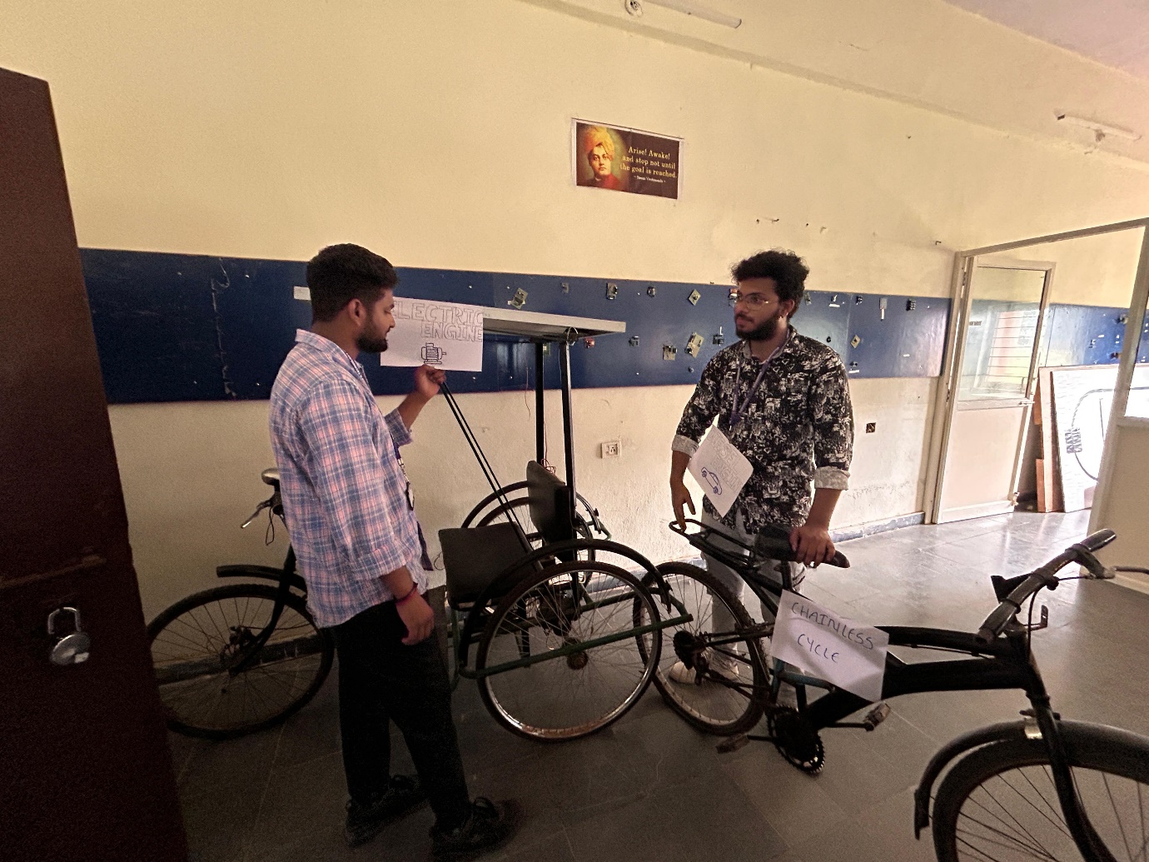
Students collaboratively working on hands-on projects to apply theoretical knowledge and develop practical skills.
IMPROVED INSTRUCTION METHODOLOGY IN LABORATORIES
Special focus is given in instruction methodology in laboratories where the emphasis is more on students’ ability to individually gain in-depth knowledge while conducting the experiments. In this regard, the following procedures are followed:
- Laboratory manuals are prepared giving the details of the procedure, specifications, etc., along with a good number of objective questions. The students have to complete the experiment and also summarize their observations of the experiment in the form of results and discussions. All the details are then written meticulously in the respective laboratory observations and then in records.
- The students are required to study the experiment and know the procedure in the manual before conduct of the experiment. The group of students is also encouraged to discuss among themselves during this study and be ready to answer any questions raised by the faculty in this regard.
QUALITY OF LABORATORY EXPERIMENTS
All laboratories are equipped with latest equipment with standard operation procedures. Students conduct experiments in group of 3. Each student prepares a lab record which is assessed by the teacher immediately after the completion of the experiment or before commencement of the next practical. Each student in the practical record indicates the collection of data and analysis along with the conclusion.
It has been observed that this method of instruction made students prepare and understand the correlation of the experiments with the related theory and also made them confident on conducting the experiment on their own.

